Jeneen Gnilka, Tim Mandel, Austin Vasquez

Project 1: AirBnb Analysis

University of Richmond Data Bootcamp

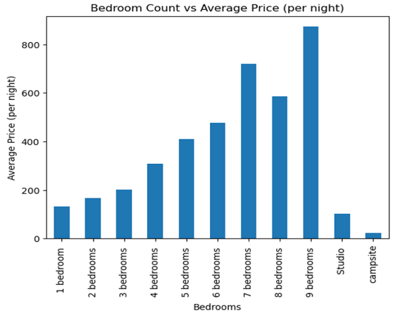Written Analysis

Price:

An initial analysis of AirBnbs in the Ashville area was conducted based on the three categories: number of bedrooms, number of beds, and number of bathrooms. As expected, the average price per night became more expensive as numbers increased in each of the three categories. Interestingly, there was only a marginal increase between number of half bathrooms in relation to number of bedrooms (i.e., a two-bedroom two and a half bath property only had a slight increase in average price per night compared to a two-bedroom two-bathroom property).

One other factor that was analyzed related to price was the type of rooms available. Excluding one-bedroom properties, other types of properties generally were divided into two groups: Entire home/apt or private room. This followed a trend counter to what people would initially hypothesize (Private room would be thought to be cheaper than an entire property). The table above breaks down the different pricing for the different room types grouped by number of bedrooms.

Reviews by Room Type:

After analyzing pricing of AirBnb properties next came the analysis related to reviews. There are 6 different weighted categories for ratings that reviews that produce a final review score presented on a property’s listing. The categories are: review scores accuracy, review scores cleanliness, review scores value, review scores communication, review scores check-in, and review scores location that are combined to create the overall review scores rating. Reviews were grouped by number of bedrooms and type of room.

Average review scores of the different categories followed a similar pattern between all data sets (number of rooms and type of rooms). One interesting point to note is how the “value” category for private rooms vs entire home was scored lower for private rooms than entire homes/apartments. This could be related to only a minimal price difference between the two types of rooms. Customers might believe they receive a “better bang for your buck” when renting an entire property instead of a private room.

Reviews By Host Size:

The last point of analysis was comparing hosts based on the total number of properties listed on AirBnb. Hosts were split into three groups: Hosts with one listing, hosts that have between 2-10 properties, and hosts that have greater than 10 properties. At initial glance, there appears to be differences in the average score ratings between the three groups. Scores follow the trend of the larger the more listings a host has, the lower overall rating is scored. One could hypothesize that this is due to the extra care single listing hosts can give than bigger hosts whom would have to take care of multiple properties. This data ultimately is what will be used to determine the answer to the question: Does the number of listings a host has correlate with the scores each receive?

Significance Test: